Dayle Hadlee
Attnded CHBS from 1961-65
Dayle joined the High School Old Boys club in 1965 and played 164 matches in his senior club career. In 194 innings he scored 3,161 runs and took 622 wickets with a best performance of nine for 27 against Sydenham on Hagley One
Excellent performances at both the National under 23 tournament and the match against the West Indian touring team gained him selection for the New Zealand team to tour England, India and Pakistan in 1969. However it was not until February 1970 that he made his debut for Canterbury. Over 11 seasons until 1984, he played 49 matches and scored 1,115 runs and took 195 wickets at 20. He scored one century and his best bowling of seven for 55 was achieved against Wellington on the Basin Reserve in January 1978. Dayle was involved in two century partnerships, 186 with Richard Leggat against Sri Lanka and a record partnership with brother Richard of 166 for the eight wicket against Auckland. Injuries severely affected his availability and he played little cricket in the early 1970’s but he recovered to have an outstanding first class season in 1972/73 with 32 wickets and in 1977/78 with 31 wickets. After missing the 1981/82 season he returned to first class cricket in 1982/83 as the Canterbury coach although later in the season he played in two matches. Dayle took the opportunity to score 109 not out against Sri Lanka.
In spite of an injury disrupted career Dayle played 58 games for New Zealand which included 26 tests. In all matches for his country he took 147 wickets and made 922 runs. He toured England in 1973 but on the 1978 tour he had to return home early when he had a recurrence of an injury His last test was at the Basin Reserve in February 1978 which New Zealand won by 72 runs, a match that was our first victory over England.
As his playing career came to a close Dayle became very involve in coaching and he eventually made the decision to terminate his teaching career where he was headmaster at the Fendalton school. In 1996 he was appointed to work for New Zealand cricket at the Lincoln Academy. Thirteen years later in 2009 Dayle moved overseas to work with the ICC in Dubai before more recently returning to work with Canterbury Cricket on a part time basis mentoring fast bowlers in the region.

Aberhart a member of the Karori club and Wairau club in Blenhiem in 1982/83 before a transfer to Lyttelton.
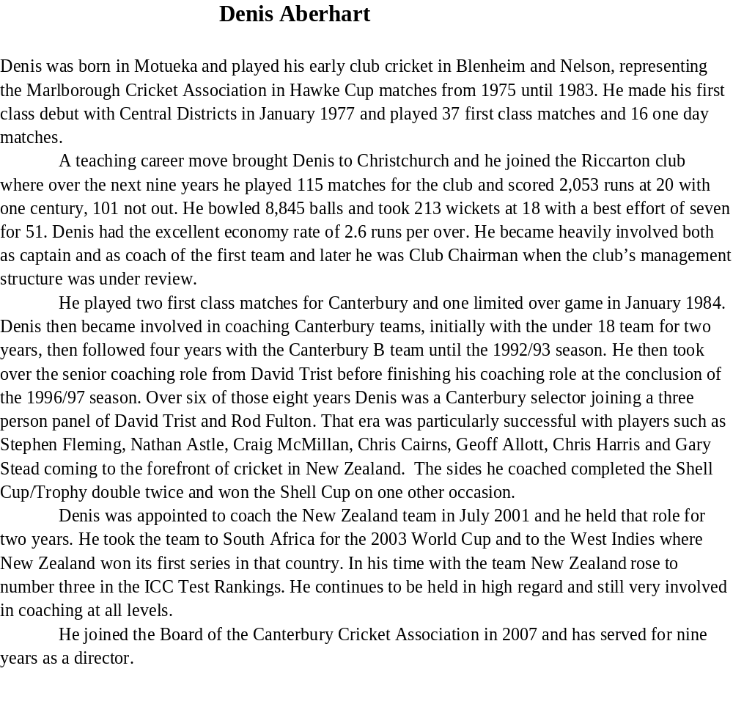

Boyle D
7879 season TO 8990 86 MTS 146 INS 23 no hs 107 not out 3,990 at 32.4 28 fifities and 2 centuries. 73 cts bowled 2654 Balls and took 57 wkts at 22
Then moved to marist and playd on until 192/93 season final career was 113 mts 187 ins 33 no hs 107 not out 5,682 runs at 36.8 two centuries and three fifities 82 cts.

Jouined marist club from 90/91 season until he retired.
Completed masters degree and given a job with canty cricket sponsor and then moved to China with the company before setting up his own, married a local girl.
Best season in 84/85 when he scored 733 runs but had scored over 500 runs in 82/83 and 86/87 and in 94/95 scored 663 runs.

Bremner MC chrisms college from 1976-??

Brownlie came from West Australia , father from Christchurch and a NZ passport and NZ citizenship his former coach was mark O’Neill who had been the NZ teams batting coach. Played 2ndXI cricket for Kent and in the Kent league in 2003 for Whitstable. in 2003 and was a member of the est Australian under 17 and under 19 team that played in the national competiion in 2001 and 2002.

Allott G played for Old Coll 44 mts 44 ins 15 no hs 26 runs 213 runs ave 7.3
135 wickets 2,224 runs ave 16.4 best bowling 7/20 five occasions he took five wickets in an innings. From 1989/90 to 1993/94 to be checked.

Aldridge Bill CHBS from 1963-64
Baker Ken CHBS from 1960-65 Got a Bsc
Brown VR 1973-77 1st xi 74-77 capt 1st xv 74 77 capt
Blain attended Nelson College from 1975 to 1976. Played HSOB 8 mts 10 ins 2 no hs 53 agg 241 ave 30.1 1 50 and 14 ct/1 st, only one season
.Bremner attended Christs College from 1976 to 1980, 1st XI 1977 to 1980, played for West Coast 1991 to 1993. Scored 2 centuries in a match in the 1989./90 season only 2 others Guillen and Hastings
He was at Medbury from 1969 to 1975 and was captain of the 1st xi in 1975.
Cuming craig capt 1st team St Albans 1996/97 season
Cummins Gerald 1972-76 CHBS

Davidson MPF at Medbury 1991-94 captain of soceer in 1994.

Dempsey CHBS from 1966 to 70
Played Old Colls from in 71 mts 117 ins 7 no 93 hs 2,813 runs at 25.5 20 fifties and took 27 wickets at 29.1 52 catches.
Flanagan CBHS from 1978 land agent
Played 101 matches 155 innings and scored 2,952 runs at 25. Highest score of 72. 16 fifties and made 45 catches. 320 wickets at 17.5.
Hartland Blair CBHS from 1980 ………..??
Hartshorn CBHS from 1979
Howell Played from 1988/89 to 1993
James Harley No 521
Sentenced June 2018 for distributing objectable child abuse images and possessing 3450 images, 65$ of which were assessed at being at the worst level of child sexual abuse. Sentenced to two years and three month prison.
He was well known in sporting and church circles and had attended a STP course for sexual offenders. He was mortified by his behavior and urged suppression of his name be granted to protect his family. (THE PRESS 24 JULY 2018)
highgate ave 27/11/1973 p18 a 2 story house 24 rooms demolished in 1973 once regarded as one of the stately homes, town houses built on site
Lawrence cwh attended Christs College form 1977 to 1981, prefect, 1st XI 1980,81 central Otago and Otago Country 1992 Bank manager in hastings, was on board of CD in 2003 previously on Board of Otago cricket. Club cricket from 1981/82 to 1988/89
43 mts 58 ins 10no hs 59 not out 790 runs 16.4 ave one fifity and 20 catches
Hetook 100 wickets at 19.7 with best bowling of 5/24 against HSOB in 1987/88
Leggat richard CBHS from 1973 to 1977, Deans Memorial Scholar ,captain 1st XI, senior sprint champion 1977
Played 133 matches and scored 5,078 runs in 213 innings highest score of 140 not out average 27. He took 141 wickets at 28. Five centuries and 27 fifties.

Fulton RW 1965-69 prefect 66-67 1st xi father cpat of 1st xi in 1943, Dip Ag Sc Lincoln in 1974, Dip VFM 1975
Masefield Attended Christs College 1969 to 1973 1st XI 1972 -73 farmer in Goughs Bay

Hounsell CHBS from 1960-64 Insurance Inspector
Smith GB CHBS from 1966-70 BSc honours
Nathu
Came from Wellington and joined the HSOB club 81 mts 148 ins 16 no 135 not out hs 4,688 runs at 35.5 average, eleven centuries and 30 fifities. 57 cts. Took 24 wickets 794 runs from 1983/84 to 1992/93.Also played for Woolston WMCC
NOON
Nottinghamshire’s Assistant Manager Wayne Noon will link up with Sydney Thunder for the entirety of their Big Bash campaign.
Noon, who has been part of Nottinghamshire’s set up as player and coach for 22 years, says he doesn’t know what to expect from his time in Australia.
“I will be throwing myself in to the unknown with the Thunder,” he said.
“I don’t know what to expect from my time there, I just hope to be able to make a difference and come back with a few more skills under my belt.
“On a personal note it will also be great to have that experience of coaching abroad on my CV after going to what is probably the second biggest T20 competition in the world.
“I wanted to challenge myself and going somewhere where I am not well known gives me the chance to leave my marker across the six weeks.
“In an ideal world I just do what I have been doing with Nottinghamshire over the years and help the Thunder during this tournament.”
With an increased number of domestic coaches heading overseas during the winter to further their coaching education, Noon follows the likes of Jason Gillespie and David Saker.
And whilst Noon goes Down Under relatively unknown, he will come up against a familiar face in the Sydney derby to kick off the tournament, as Michael Lumb lines up with the Sixers.
“It was talked about by the ECB throughout the summer that English coaches were lacking experience of coaching abroad,” Noon said.
“So, after talking to Mick, it was decided that I would put some feelers out and pass on my CV to all the franchises in Australia.
“I also think that Dave Hussey passed on a good word to his brother Mike, captain of Thunder, and from there a few phone calls later and I had my position for the winter secured.
“I have been working with Lumby over the winter so far and as soon as he found out I was going he started badgering me with quotes like ‘enjoy the wooden spoon’.”
Rattray PJ captain 1st XI 1976 Rattray CBHS from 1972 to 1976
played for the HSOB club from 1976/77 to 1991/92. He played 111 matches and in 190 innings he scored 4,56 runs at 27 with a highest score of 113 not out. He made four centureis and 19 fifities and took 48 ctaches. In a brief career as a bowler he took five wickets at 30. ,
Richards, attended Christs College from 1981 to 1984, 1st XI 1984
Roberts SJ CBHS from 1978 until 1993played for HSOB in 90 mts 89 ins no 16 hs 43 runs 885 at 12.3 ave 35 cts bowled 10,605 overs and took 297 wickets 18.8 runs off 5587. Best bowling was 7/19 and took five wickets in an innings on 9 occasions. Did not play in 1st xi at school
Senior cricket from 1983/84 to 1995/96 at least.

Ritchie BD CHBS from 1968-73
Hayden Jonathan Shaw born August 31, 1980 in Christchurch) is a field hockey player from New Zealand, who earned his first cap for the national team, nicknamed The Black Sticks, in 2002 against Australia.Shaw is often involved in penalty corner set moves and can perform a drag flick shot. Shaw also plays first class cricket for CanterburyAt the completion of the 2006 Men's Hockey World Cup, Shaw was selected for the World Cup All Star team. Shaw has also played for HC Den Bosch in the Netherlands hockey for Selwyn club
Wright JG attended Christs College from 1967 to 1971 prefect 1st XI 1969 to 1971. BSc Otago. MBE 1989.
On his test debut he wa scaught behind off Biob Willis but given not out and went on to score 55 in 348 minutes. Played a significant part in the victory over England. He was considered one of NZ grittiest batsman, played 832 tets, scored 5,334 runs at 37.8 (12 centuries and two 99’s. Captain NZ in 14 matches with 3 wins, eight draws, head boy at Christ college started a BSc at Otago, university, played under age cricket for canterbury but moved to ND to gain his firat class debut, in 1976, in 1977 signed for Derbyshire in 197 and stayed 12 seasons, Redpath cup won in 19900 and 1992. Was a reliable and enthusiastic fielder he was practicable joker and gained total repsect form his opponents, later coached at Kent before coachin g indian team loved to use his guitar. CC from 1967 to 1971 1st XI from 69-71 captain in 1971, 1st XV 1971 prefect, Basketball gained a BSC at Otago in 1975 MBE in 1989.
Played 22 mts 37 ins 3 no 65 hs 758 runs 2 ave three fifities six catches these are 1971/72 to 1975/76
.
Englefield holds record for most centuries in a club season for St Albans

Flanagan 7 for 3 against C C in 1981 CBHS 176/8d and 59 CC 65 following on 196 .

Lawrence in above match took 4 for 17 to win for College 1st XV in 1981.
John Gully, Founder of Everest Treks, developed a passion for mountaineering in the Southern Alps of New Zealand, and managed a number of Himalayan summit attempts in the 1980s, including three expeditions to Mt Everest. Since establishing Everest Treks John has led hundreds of people and scores of treks to the Everest region attended Nelson College from1970 to 1974 1st XI 1971 74 1sst XV 1974, junior Athletic champion in 1972. In 1981 went to live in Kalamunda WA and become a groundsman, very keen alpine climber and spent time in the Himalaylas. Was club personality club member in 1982/83 Joined the club in 1982/83 and last season was 1985/86 Had 23seasons for 22 m 36 ins 1 no 72 hs 736 runs 21.0 ave 30 balls 1/24 5cts 1982/83 and 1983/84 1985/86
Nelson College 1st XI in 1971 to 1974
Awarded QSM in New years list of 2013 for services to NZ Nepal relations.

Hartland B CBHS from 1980to ??
HSOB from 1984/85 to 1993/94 70 matches 52 innings 11 no hs 112 runs 1,278 at 28.4 one century and 17 half centuries. 40 catches

Lefevre LP WWMCC seven matches and scored 322 runs in 10 innings at 32.2 average. Highest score 89. Four fifties and took 14 wickets at 24.8
.

Miller attended CBHS from 1993-97

Petrie member of the Karori club from 1990 to 2008
l played for St Albans one season 1956/57 and took 31 wickets at 18 from 182 overs

Taylor 31 draper st in 1978 labourer 48 oriana crescent driver

Tracy Old Collegians club 10 matches seven innings and scored 37 runs with a highest score of 21. He took 27 wickets at 18.7, best bowling was 5/53 against LP.
Only one season 1985/86
Had one season for Otago five years later. Began his career with Auckland in the 1982/83 season and again the following season before moving to Canterbury , played for NZ on 1983 tour and also Zimbabawe in 1984 Played for south canty in January 1949
Unwin no club records with rtb probably one season in 1993/94
Vermeulen attended Shirley BHS, 1996 -2000, 1st XI last year, only started cricket at age 15, was in wider training group with CCA, had a seven wicket bag in club cricket prior to call up, was at a wedding in banks Penisula on Sat was the best man and then flew to Auckland, spent 2010/11 injured hamstring and knee, went to Holland in 2011 winter, father was born in Holland, got injured in first game in 2011/12 season. Bowls outswing around 130k
.
Wilson came form Nelson played for 13 mts 23 ins hs 77 runs 541 at 23.6 two fifities

Ward JS was a horticultural worker later working in MacKenzie Country in a home stay business

Wiseman from 01/02 to 05/06
34 mts 47 ins 7 no 132 hs 1,262 runs 31.5 ave one century and six half centuries 16 catches took 58 wickets at 19.5 best bowling 5/47 one five wicket bag.

Yock 89 matches and scored 3,114 runs in 140 innings highest score of 130. There were three centuries and 11 half centuries. He made 16 catches and 18 stumpings.

Last season 2002/03 started 1994/95

